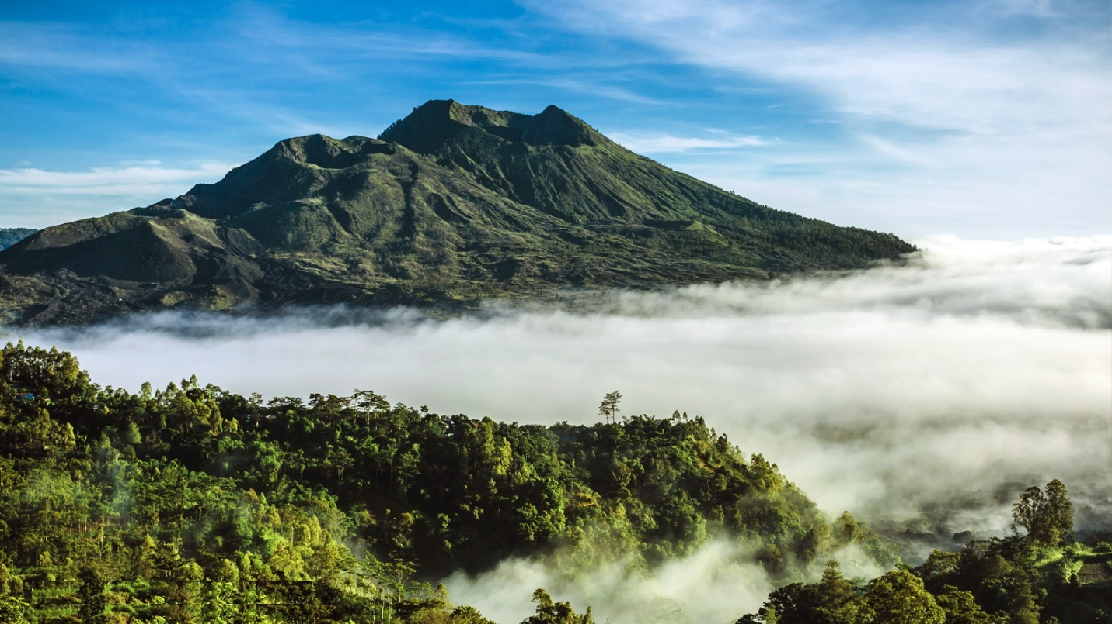

Full day Tour ; Kintamani

The viewing of mount batur and lake batur

Goa Gajah, Elephant cave temple

Tirtha empul Hot spring temple

Tegallalang beautiful rice terrace

Bali Coffee Plantation

Kintamani Regular Tours Price :
IDR. 750.000/car ( 1 till 5 person included)
IDR. 1.100.000/minibus ( 1 till 10 person included)
IDR. 1.300.000/minibus ( 1 till 15 person included)
IDR. 2.000.000/bus ( 1 till 30 person included)
Inclusion : Private Car / Minibus / Bus + Petrol + English Speaking Driver
Note : Entrance fee and meals is not include in the price

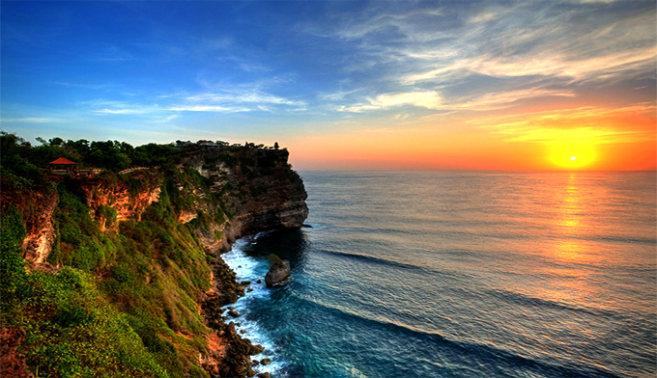

Full day Tour ; Uluwatu
Garuda Wisnu Kencana
Padang - Padang Beach
Uluwatu Temple
Kecak and Fire Dance Performance
Seafood dinner at Jimbaran Beach
Full Day Uluwatu Regular Tours Price :
IDR. 750.000/car ( 1 till 5 person included)
IDR. 1.100.000/minibus ( 1 till 10 person included)
IDR. 1.300.000/minibus ( 1 till 15 person included)
IDR. 2.000.000/bus ( 1 till 30 person included)
Inclusion : Private Car / Minibus / Bus + Petrol + English Speaking Driver
Note : Entrance fee, dinner, meals and kecak dance performance is not include in the price

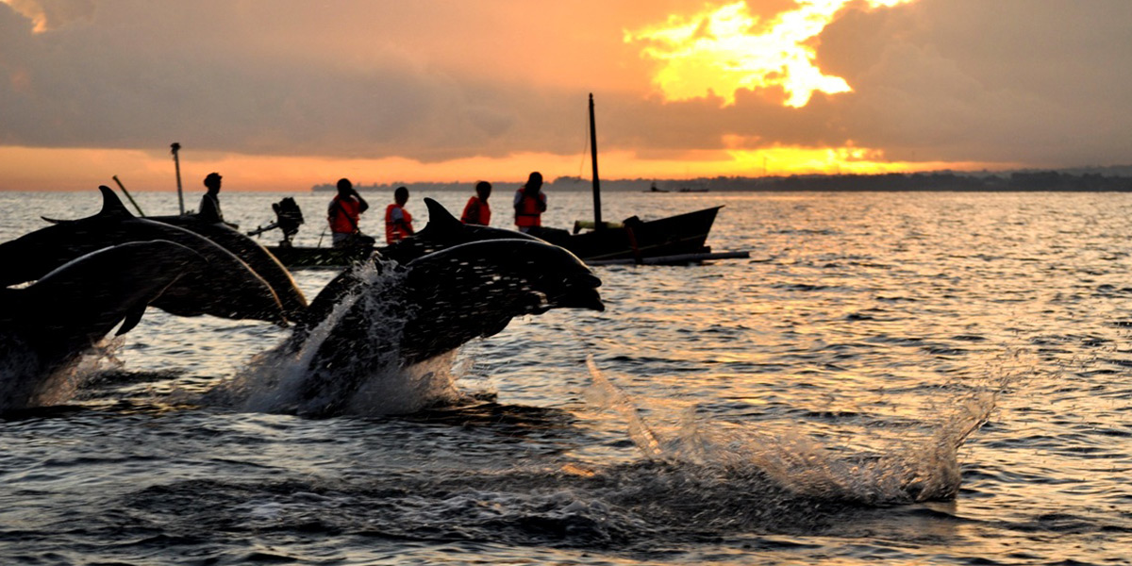

Full day Tour ; Bali Dolphin
Lovina Beach
Traditional boat to see dolphin to the sea
Gitgit Waterfall
Ulun Danu Beratan Temple
Full day Tour Bali Dolphin Regular Tours Price:
IDR. 750.000/car ( 1 till 5 person included)
IDR. 1.100.000/minibus ( 1 till 10 person included)
IDR. 1.300.000/minibus ( 1 till 15 person included)
IDR. 2.000.000/bus ( 1 till 30 person included)
Inclusion : Private Car / Minibus / Bus + Petrol + English Speaking Driver
Note : Entrance fee, Rent traditional boat and Lunch is not include in the price

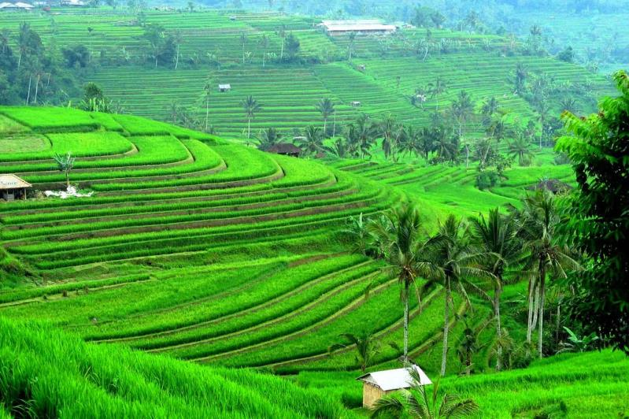

Full day Tour ; Jatiluwih and Tanah Lot
Taman Ayun Temple
Bali Coffee Plantation
Ulun Danu Beratan Temple
Jatiluwih Rice Terrace
Tanah Lot Temple
Jatiluwih and Tanah Lot Sunset Tour Regular Tours Price :
IDR. 750.000/car ( 1 till 5 person included)
IDR. 1.100.000/minibus ( 1 till 10 person included)
IDR. 1.300.000/minibus ( 1 till 15 person included)
IDR. 2.000.000/bus ( 1 till 30 person included)
Inclusion : Private Car / Minibus / Bus + Petrol + English Speaking Driver
Note : Entrance fee and Lunch is not include in the price

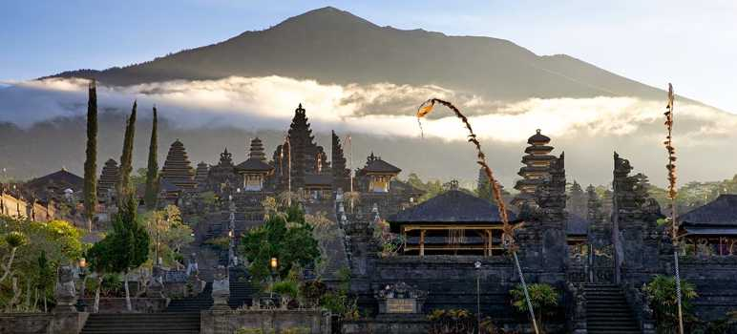

Full day Tour ; Kintamani Besakih
Barong Dance Performance
Celuk Village for Gold and Silver Art
Batuan Village for Painting Art
Tegalalang Rice Terrace
Kintamani Volcano View
Besakih Temple
Kintamani Besakih Tour Regular Tours Price :
IDR. 750.000/car ( 1 till 5 person included)
IDR. 1.100.000/minibus ( 1 till 10 person included)
IDR. 1.300.000/minibus ( 1 till 15 person included)
IDR. 2.000.000/bus ( 1 till 30 person included)
Inclusion : Private Car / Minibus / Bus + Petrol + English Speaking Driver
Note : Entrance fee and meals is not include in the price and you will need to pay "Local Guide Fee" at Besakih Temple

Full day Tour ; Bedugul
Taman Ayun Temple
Bali Coffee Plantation
Bedugul Botanical Garden
Ulun Danu Beratan Temple
Candi Kuning Market
Bedugul Tour Regular Tours Price :
IDR. 750.000/car ( 1 till 6 person included)
IDR. 1.200.000/minibus ( 1 till 12 person included)
IDR. 2.000.000/minibus ( 1 till 17 person included)
IDR. 2.500.000/bus ( 1 till 30 person included)
Inclusion : Private Car / Minibus / Bus + Petrol + English Speaking Driver
Note : Entrance fee and meals is not include in the price

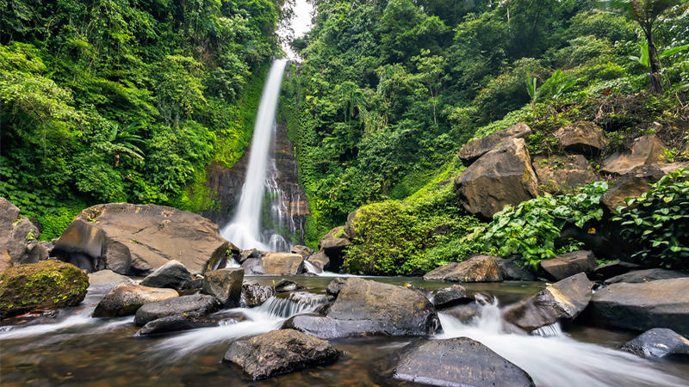

Full day Tour ; North Bali
Ulun Danu Beratan Temple
Tamblingan and Buyan Twin Lake View
Gitgit Waterfall
Lovina Beach
Banjar Hot Water Spring
Fullday North Bali Tour Regular Tours Price :
IDR. 750.000/car ( 1 till 5 person included)
IDR. 1.100.000/minibus ( 1 till 10 person included)
IDR. 1.300.000/minibus ( 1 till 15 person included)
IDR. 2.000.000/bus ( 1 till 30 person included)
Inclusion : Private Car / Minibus / Bus + Petrol + English Speaking Driver
Note : Entrance fee and Meals is not include in the price

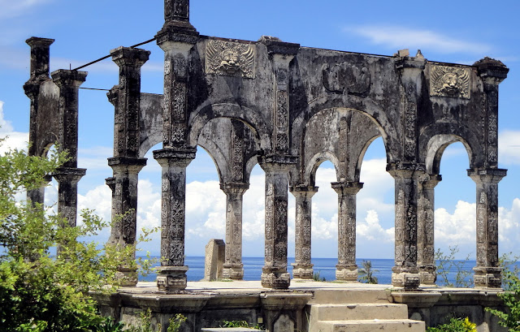

Full day Tour ; East Bali
Goa Lawah Temple / Bat Cave Temple
Tenganan Village
Ujung Water Palace
Tirta Gangga
East Bali Tour Regular Tours Price :
IDR. 750.000/car ( 1 till 5 person included)
IDR. 1.100.000/minibus ( 1 till 10 person included)
IDR. 1.300.000/minibus ( 1 till 15 person included)
IDR. 2.000.000/bus ( 1 till 30 person included)
Inclusion : Private Car / Minibus / Bus + Petrol + English Speaking Driver
Note : Entrance fee and meals is not include in the price

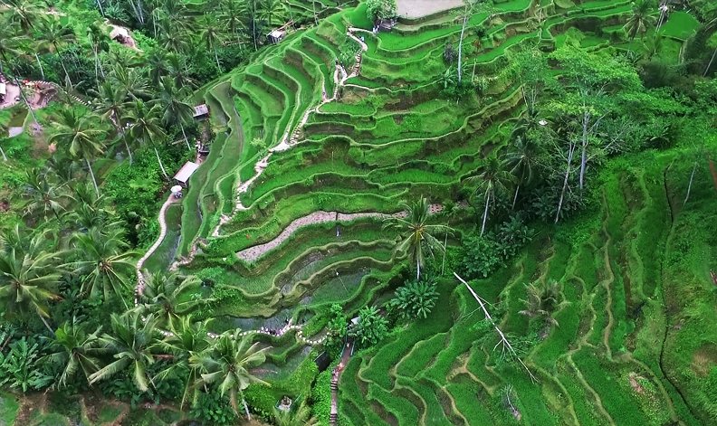

Half day Tour ; Tampaksiring

Tegallalang beautiful rice terrace

Tirtha empul Hot spring temple
Bali Coffee Plantation
Bedugul Tour Regular Tours Price :
IDR. 450.000/car ( 1 till 5 person included)
Inclusion : Private Car + Petrol + English Speaking Driver
Note : Entrance fee and meals is not include in the price

Half day Tour ; Tegallalang

Goa Gajah, Elephant cave temple

Gunung Kawi, the Rocky Temple

Tegallalang beautiful rice terrace
Bedugul Tour Regular Tours Price :
IDR. 450.000/car ( 1 till 5 person included)
Inclusion : Private Car + Petrol + English Speaking Driver
Note : Entrance fee and meals is not include in the price

Terms and Conditions
Terms Payment
- Payment receive by Cash, Credit card and online payment system (Doku or PayPal).
- Payment is on the day itself with our reception.
- Payment can be transfer to your room’s bill folio and pay upon your departure time.
Terms of Conditions
- Full day tours duration is 8 hours
- Half day tours duration is 5 hours
- The price already include with 21% Government tax and Services
- Get special price for group booking
- The tour is Private Tours, means there is no other participant, just only you and your companion
- The tour will assist by English Speaking Tours Driver
- Tour Guide can be requested, contact us if you want to request tour Guide during the trip on additional charges.
- Time and Tourism site is subject to change based on your request.
- Use contact form provide to send us message, asking information or make tour booking request.
How to Book
- Choose which Bali Full Day Tour / Half Day Trip Tour package that you want to book.
- Fill The Booking Form with name, room number and make sure you put valid email address.
- After we received your Tour or Activity booking request we will reconfirm again your booking request, to make sure all request is correct.
- After everything is clear, we will send the booking confirmation for finalized your booking
Cancelation Policy
- Cancellation fee to 50% of the TOTAL payment will be charged if a confirmed booking is cancelled within one day prior to clients pick up
Privacy Policy
Your reservation is absolutely secure. We takes the privacy of your personal data very seriously, your personal information will only be used to process your booking.

